|  |  |  |  |  |  |  |  |  |  |
| --- | --- | --- | --- | --- | --- | --- | --- | --- | --- |
|  |  | **INTERSTATE CONTAINER CORPORATION** | | | | | ***Date:* 05/05/2015** | | ***Spec #:*** |
|  |  | ***Customer:*** | **DeMet's Candy** |  |  |  |  |  |  |
|  |  | ***Description:*** | **4 ct - Satin Hearts 6.5oz** | | | |  |  |  |
| ***Style:* HSC TOP/123 BTM** | | | | ***Revision Info:* [0] 05/04/2015:** | | |  |  |  |
| ***I.D. :* 6+1/4 x 9+1/16 x 5+1/4** | | | | ***Blank size:* 20 x 32+13/16** | | |  |  |  |
| ***Board:* 32 E K** | | |  | ***Combination:* 35HP - 23M - 35HP** | | | ***Designer:* Brian Romankow** | | |
|  |  |  |  |  |  |  |  |  |  |
|  | |  |  |  |  |  |  |  |  |
| 33*/*8 | | |  |  |  |  |  |  |  |
|  |  |  |  |  |  |  |  |  |  |
|  |  |  |  |  |  |  |  |  |  |

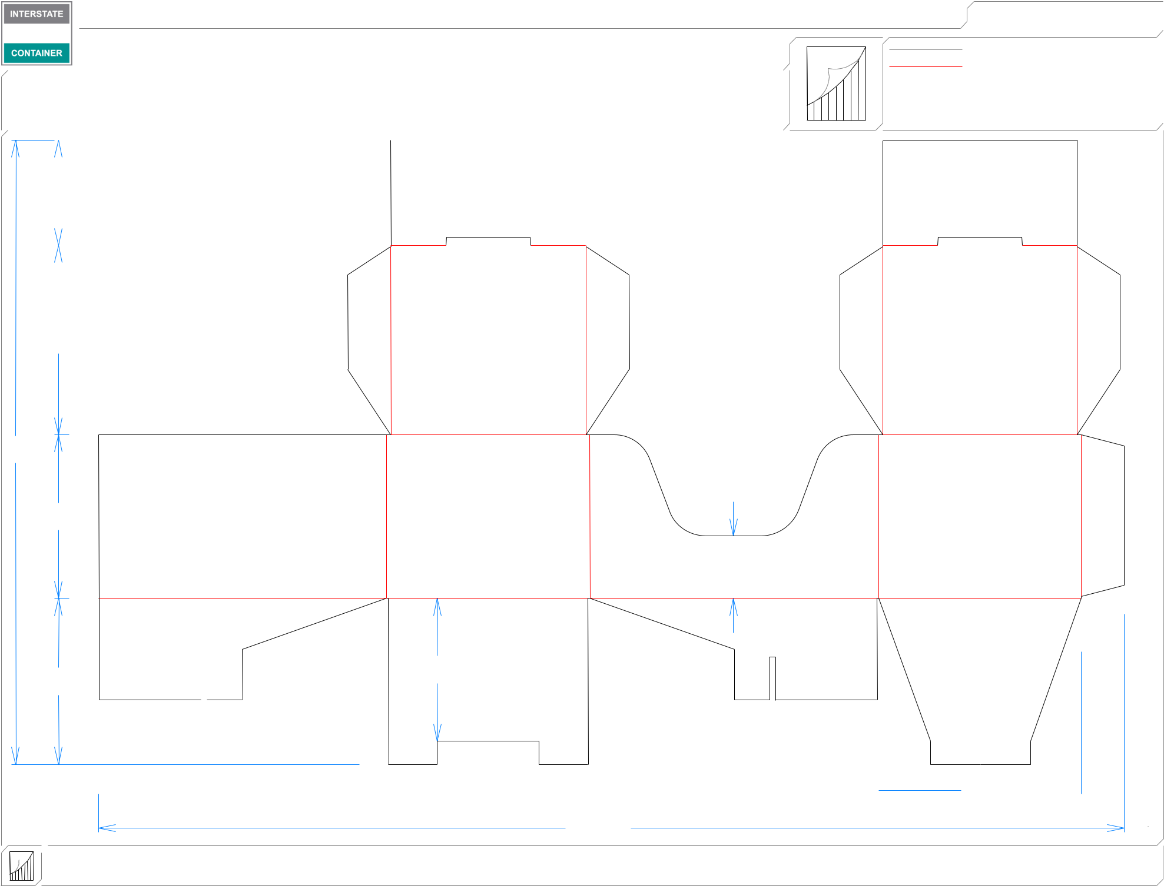

61*/*16

20

51*/*4

2

|  |  |  |  |  |  |
| --- | --- | --- | --- | --- | --- |
| 55*/*16 |  | 49*/*16 | | |  |
|  |  |  |  |  |  |

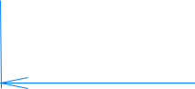 91*/*4  61*/*2  91*/*4 

3213*/*16

|  |  |  |  |
| --- | --- | --- | --- |
| ***Design #:*** | **150426-01** |  |  |
|  |  |  |
| ***Cut*** | **170 in.** |  |  |
|  |  |
| ***Crease*** | **96 in.** |  |  |
|  |  |  |  |

61*/*2  13*/*8 

**inside view**

**Vertical Corrugation**

***notes:***

***Qty/unit:*** ***Area - waste:* 2.71 sq. ft** ***Waste on blank:* 40.4%** ***Piece weight - waste:* 0.28 lbs./125.06 g**